Our ref: | CYP
Your ref: | CR
Please contact: | Catherine Rhodes
Telephone: | 01422 261244
Freephone | 0800 3895785
E-mail: | Catherine.rhodes2@calderdale.gov.uk
Date:

 | Children and Young People’s Services
 | Calderdale Young Carers Service
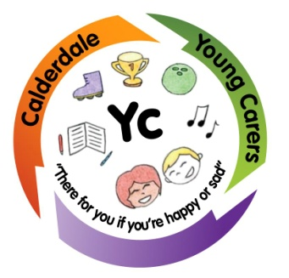 | Council Offices  Southgate  Elland  HX5 OER
Re: Young Carers Passport

Dear ……,

As you may be aware Calderdale Young Carers with the help of some young carers and the Youth Parliament, have created a Young Carers Passport. In order for your school to support you as a young carer you will require a school passport. I have enclosed an application form and guidelines.

It can be used within school when you feel you are struggling due to caring responsibilities. There are 3 sections to the passport.
1. Telephone
2. Time Out
3. Homework

The Telephone part may be shown to the teacher when you need to make a call home to settle your mind. Time out is to be used when you need a few minutes outside of the lesson due to being upset, someone will come and chat to you about this after, this is not an excuse to just leave the lessons you don't like! The Homework option is to be used when you have fallen behind with homework– again no questions will be asked on the spot but a teacher will approach you after to see if you are ok. When you show your card, it will be signed on the back by your teacher and when this is full, please pass to Ms Pickles, she will return to us, a new one will then be issued.

How to get your passport
To get your hands on your very own passport, read through the enclosed information with a parent or carer and make sure you understand how to use your passport, and then complete the application form. We need all your details first, then your parent or carers details. The next part is to be filled in by school and signed by them. Your school lead is Ms Pickles; therefore it is this person that needs to fill this bit in. Only thing left to do is enclose a passport sized photo or ask school to enclose one, and then post back to us. When we receive all this, we will give you a membership number and post your passport to you.

If you have any questions at all about the application form or how to use the passport I will be more than happy to chat to you on the phone or visit you at home to answer any concerns.
My telephone number is 01422 261244 or 0800 3895785, if I am not there, leave me a message and I will call you back as soon as possible.
Thank you and I look forward to receiving your completed applications in the post.
Catherine Rhodes
Young Carers Specialist Worker

